

**Java ZOne & Bistro**

Ashwin Graphics



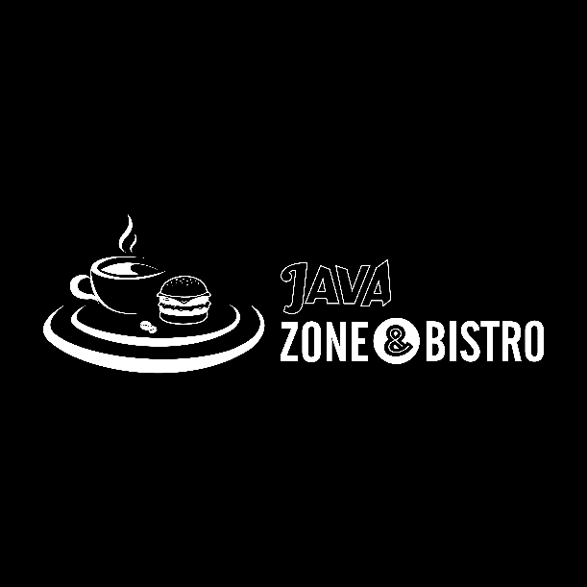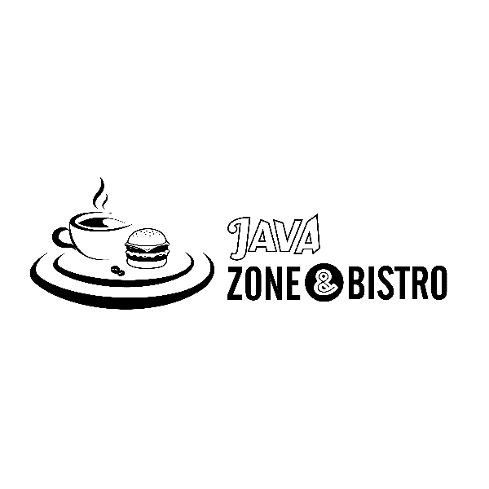

**1. About the Concept:**

* Java Zone and Bistro is a Café and the change of fonts focus more on the zone and bistro which means the service that the café provides are more than just a coffee.
* The coffee and burger depict more about café that Java Zone and Bistro provides freshness and hunger Solutions.
* This Design is suitable for brandings.

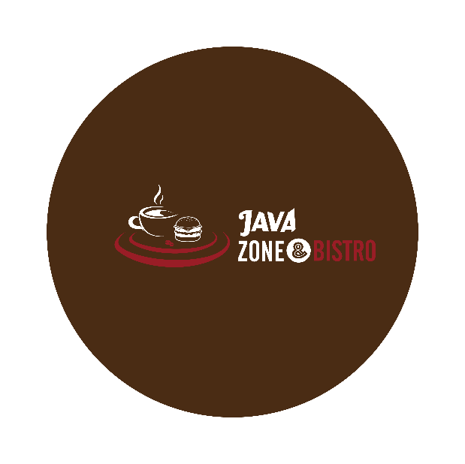

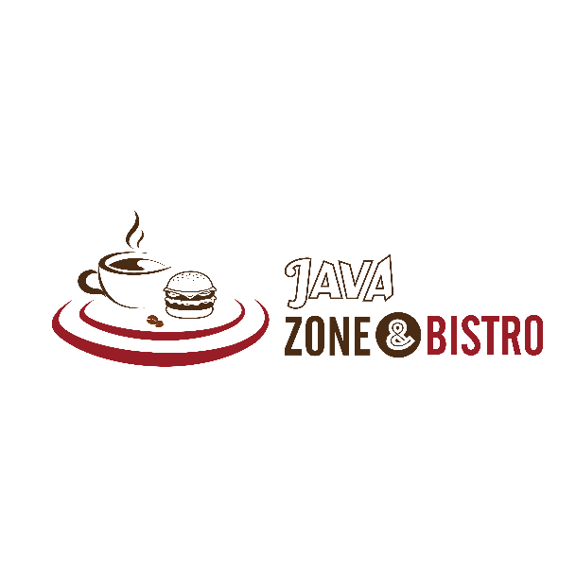

**.**

**2. Colours Concept:**

* Java Zone and Bistro’s Logo Psychology is used with Brown for coffee and Maroon for the hunger satisfaction.